AP Music Theory Paper Free Response Questions.

Complete these Free Response Questions as your homework while you do not have internet access. Do your best to complete these in the “suggested time” to help you prepare for the exam.

- Assignment 1
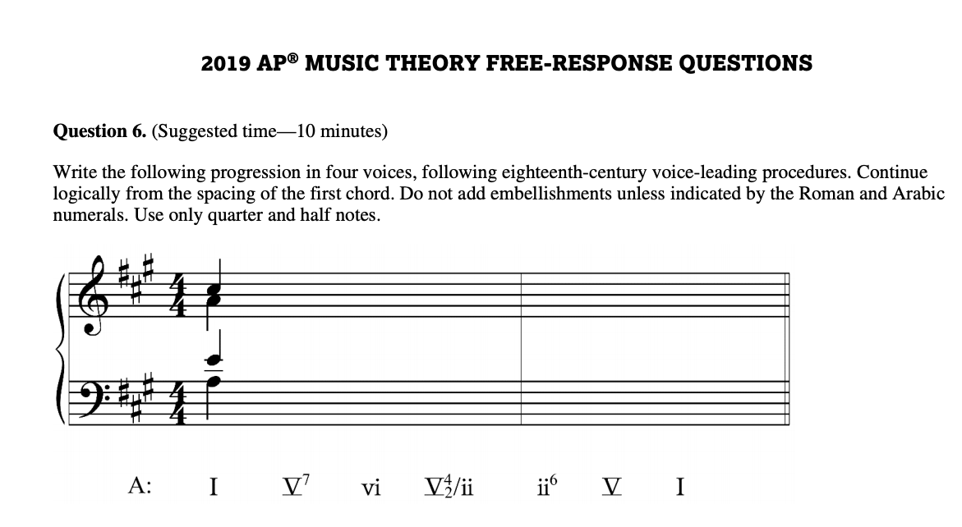

- Assignment 2
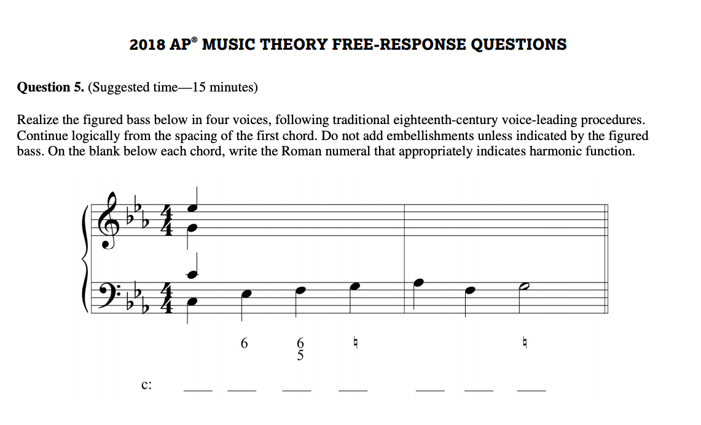
- Assignment 3
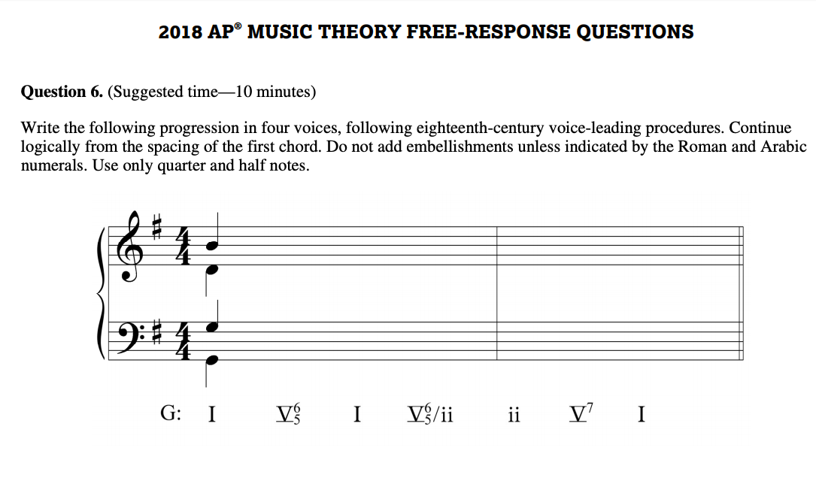

- Assignment 4
- Assignment 5
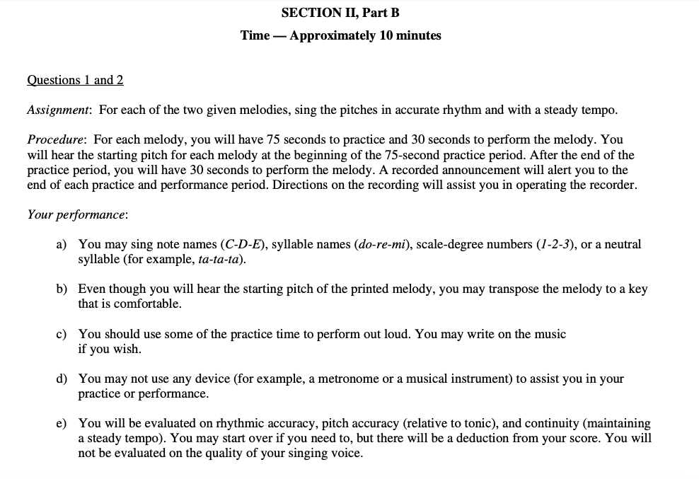

- Assignment 6

